## Project Original Mobile App Progress: **PETSHARE**

**Goals:** The goal of this app is to create an app that allows people to rent other people's dogs. There are so many people who can’t have animals long-term for various reasons but want the companionship of dogs sometime. Also, with dog sitters so hard to find for reasonable prices, both parties can create agreements of times to rent the dog. The goal is for the transaction to be free for both parties other than the initial background check fee that the Sharee (person asking to temporarily keep the dog) pays. This creates solutions for those looking to save money when it comes to paying dog sitters, as well as allows those without dogs to experience what it’s like to have certain dogs and give them short term experience with the dogs if they can’t have them long term. This solves two real world issues, so that is why I think it would be a useful app.

**Progress:** So far the progress has been excellent. The wireframing for the app is laid out in the simplest manner to get the idea and functionality of the app across to investors so they can see the roots of what they are investing in as a prototype. For the app I have laid out a Splash page that shows the app name and slogan. After the Splash page dissipates, a login screen will be presented for those who already have an account, and if they don’t have an account, they can be taken to the sign-up page. After leaving either of these pages, the client will be led to a home screen/search screen where they can see dogs within a 50-mile radius. From this screen they can search for dogs which will populate dogs of the breed searched for within that 50-mile radius. They can then select a dog and a profile for that dog will be displayed. On that profile will be the information for the owner/Sharer, and they can initiate contact from there. Once contact is made, they can negotiate times to meet up. In order for the Sharee to get rent the dog from the sharer, they have to perform a background check first. After this check is conducted and successful, the Sharer can notify the Sharee and find times to meet to hand over the dog to be Shared. This is as far as progress has come with the app. Later a team of developers and I will further the app, fixing hiccups with the apps as they arise.

**PETSHARE** 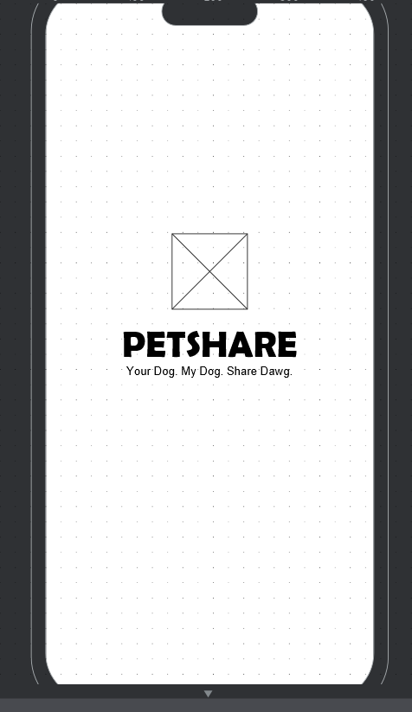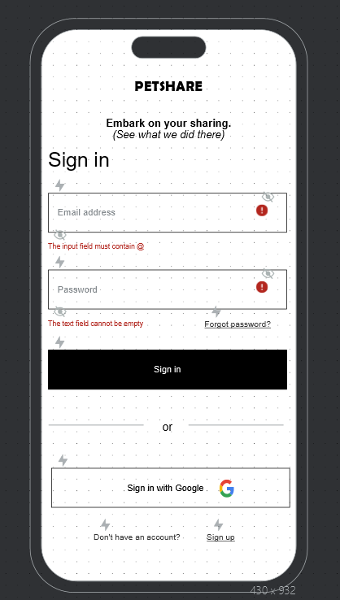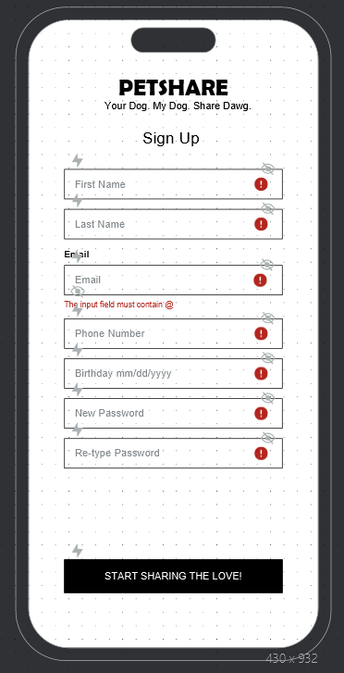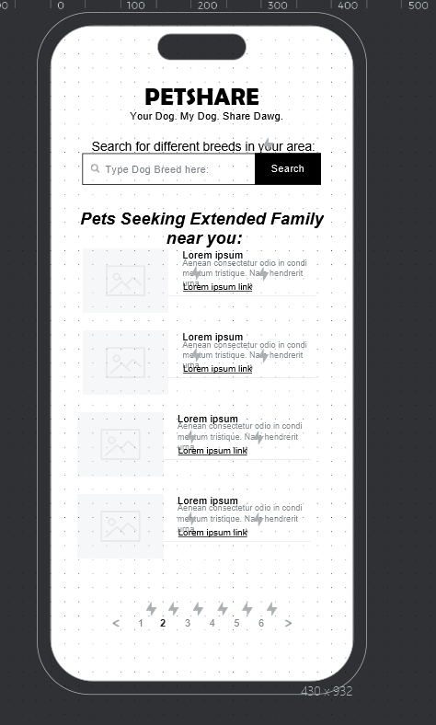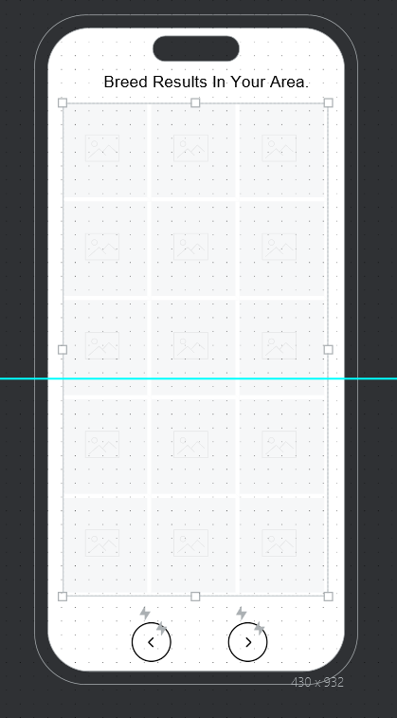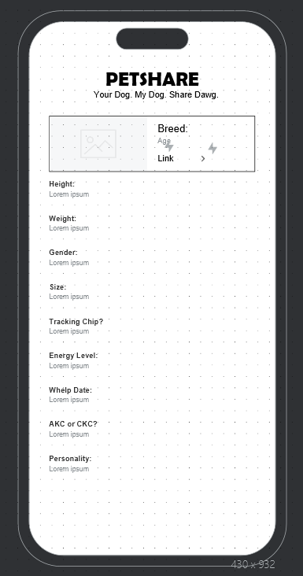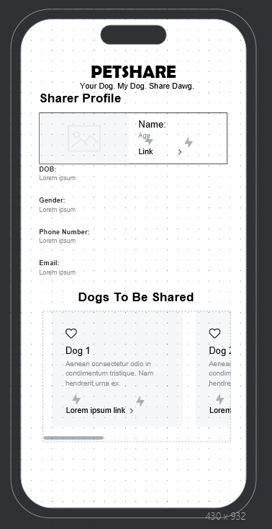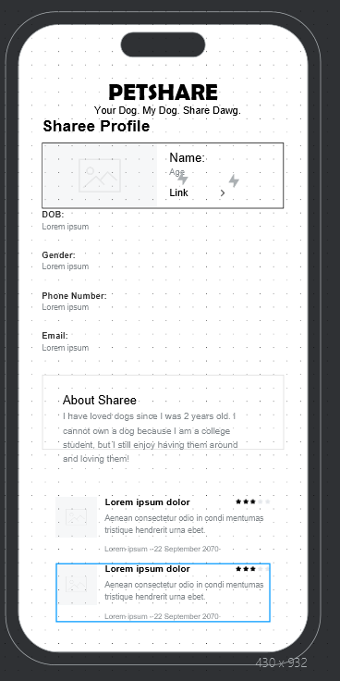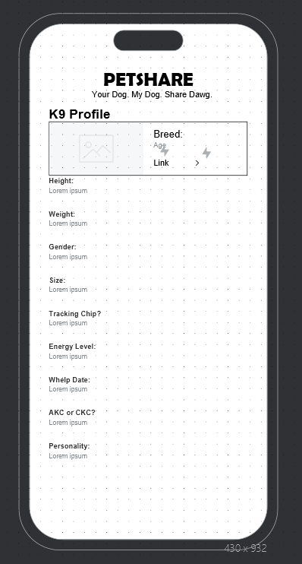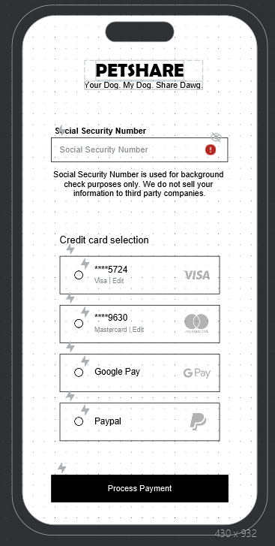

**Processes used:** Processes used are: For the app there are many processes used. The process starts at the Splash page, which has a timeout to destroy the page after a few seconds. Next, will be the ability to input data to login against data in the database to verify the user. If the user doesn’t have an account, they can enter a new entry into the database for themselves. All fields must be filled correctly especially for required fields. After signing up there will be a search feature to see what dogs are within 50-miles. The results will post as a Gridview, and the Sharee can toggle through the search pages to see all the dogs available to them. Once a dog is chosen the Sharee can use a built in Instant message feature to talk with the Sharer of the dog. Once they both converse, the Sharee can fill out information from a private class for secure information such as their social security number to conduct their background check. All mockups above were made in Justinmind, and will be created further in Android Studio. SQLite will be used for the database due to its lightweight nature.